# **Format for uploading details in GitHub and Slack in word file format**

**Student Name: Shrinivasa**

**Class and Sec: VI B**

**USN: 4AL17CS092**

|  |  |  |  |  |
| --- | --- | --- | --- | --- |
| **Online Test Details** | | | | |
| **Subject** | **Python (Workshop quiz)** | | | |
| **Semester** | **VI - B** | | **Duration** | **30 Minutes** |
| **95%** | | **19/20** | | |

**Encl: snapshot of the test result**

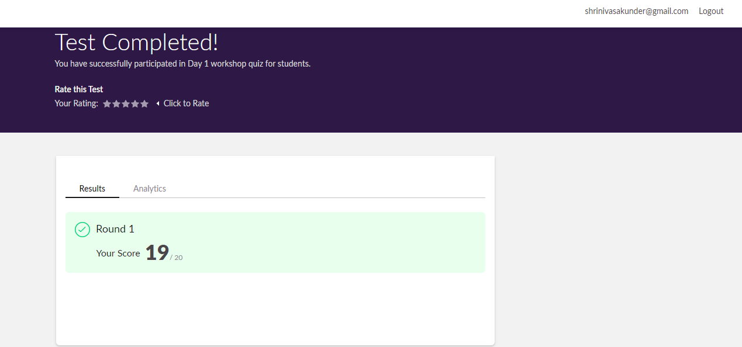

|  |  |  |  |
| --- | --- | --- | --- |
| **Pre-Placement Training Summary** | | | |
| **Pre placement training** | **9:00 am to 11:00 am - Programming in C**  **11:00 am to 1:00pm - Applications of python in DA and ML** | | |
| **Faculty** | **Vivek Sharma,**  **Dr. Mohideen Badusha** | **Duration** | **4 hours** |

**Encl: snapshots of the daily class activities (at least two snap shots)**

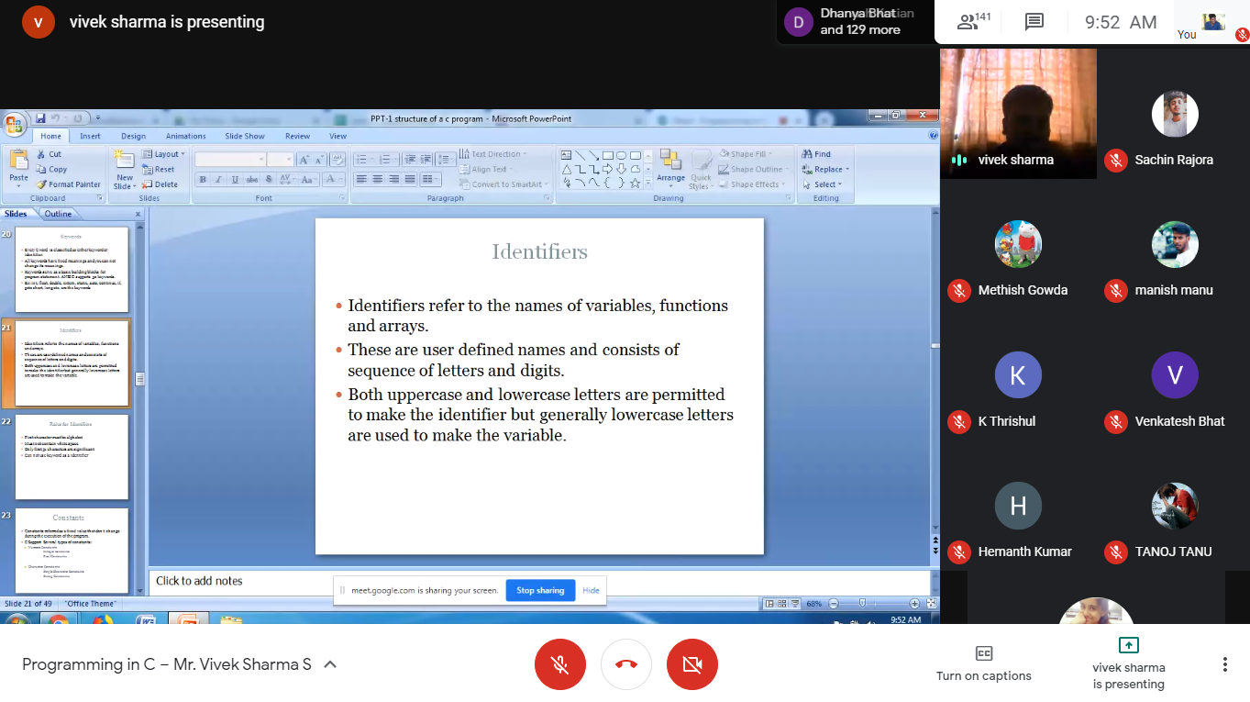

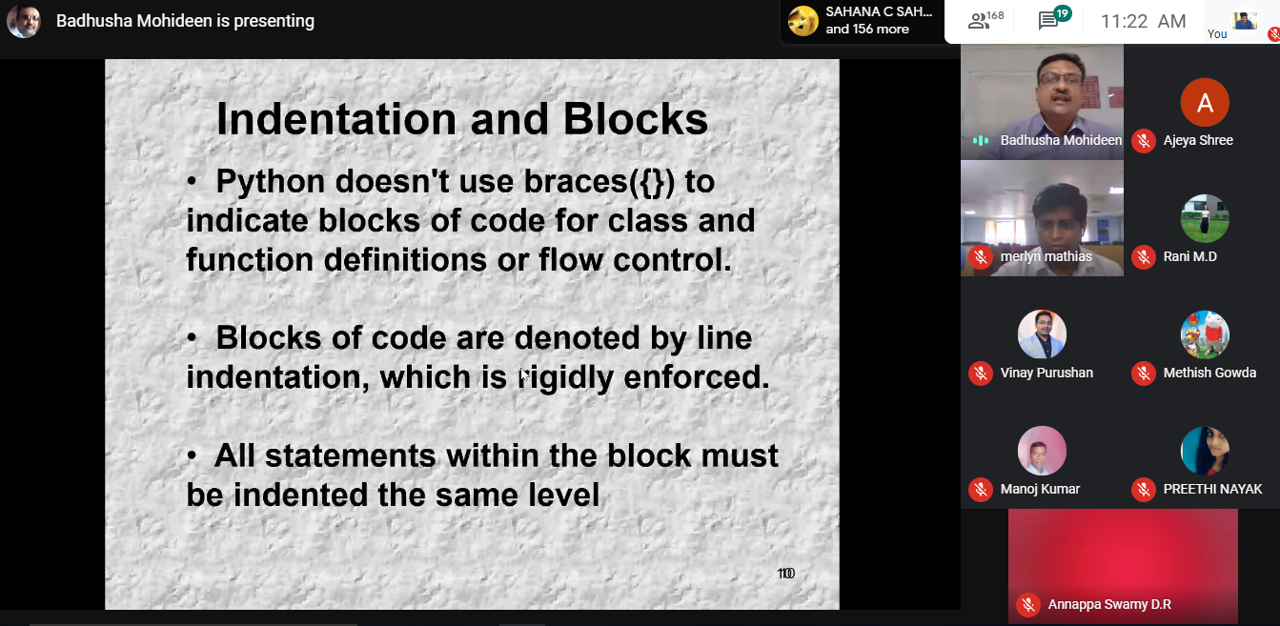

|  |  |
| --- | --- |
| **Coding Challenges** | |
| **Problem Statement: 1. C program to count number of distinct elements in an array.**  **2. Examples and Exercises on python. (Linked Google-colab to GitHub)**  [**https://github.com/Shrinivasakunder/certification-and-online-coding**](https://github.com/Shrinivasakunder/certification-and-online-coding) | |
| **Status: Completed** | |
| **Uploaded the report both in GitHub & Slack** | **Yes** |

**Encl: snapshots of your response to challenge.**

**C program to count distinct elements in an array.**

#include <stdio.h>

void distict_elements(int a[], int n);

int main()

{

int size_array, i, arr[20];

printf("enter the size of the array: ");

scanf("%d", &size_array);

printf("enter the array elements: ");

for(i=0; i<size_array; i++)

{

scanf("%d", &arr[i]);

}

distict_elements(arr, size_array);

return 0;

}

void distict_elements(int a[], int n)

{

int i, j;

for (i=0; i<n; i++)

{

for (j=0; j<i; j++)

{

if (a[i] == a[j])

break;

}

if (i == j)

printf("%d ",a[i]);

}

}

**Output:**

